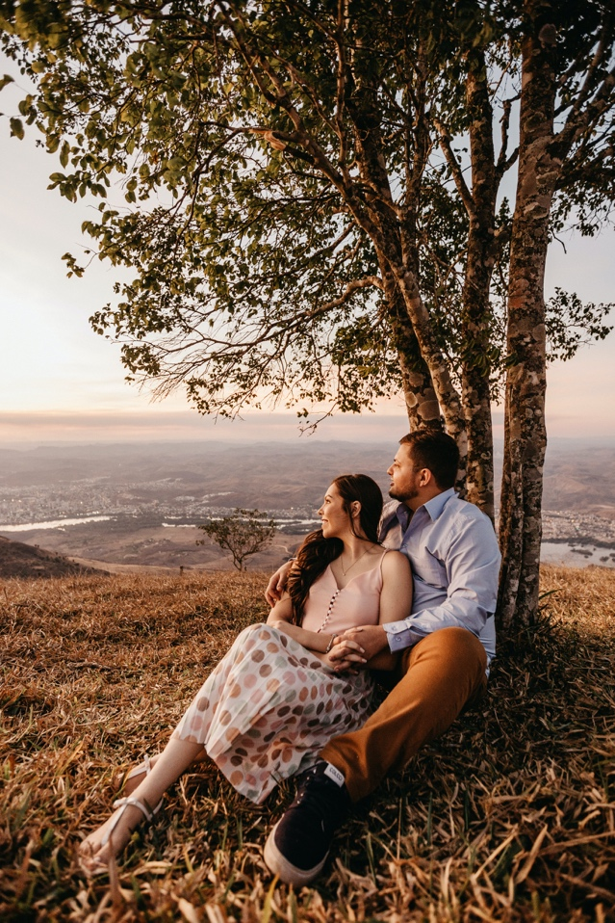
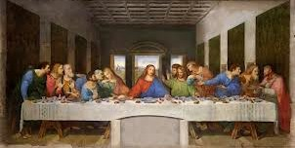
Gift Bearers
The Brady Family

Special Thanks to Tommy Lascelles
Thank you for joining Michael and Holly as they enter the sacrament of marriage.
MARRIAGE SACRAMENT
Celebrant
Rev. Fr. Matias Perez Constanzo

Maid of Honor
Elaine Benes, Sister of Bride

Best Man
Joshua Nichols, Nephew of the Bride

Bridesmaids
Jane Villanueva, Friend of the Bride Claire Foy, Friend of the Bride Olivia Colman, Friend of the Bride Molly Hooper, Friend of the Bride

Groomsmen
Drake Parker, Friend of the Groom Ned Bigby, Friend of the Groom Sterling Brown, Cousin of the Groom Ian Malcolm, Brother of the Groom

Readers
First Reading – Jen Mosely Second Reading – Suzie Crabgrass

Music
Sam Cooke
Taylor Swift
Maecenas
Curabitur leo
THE MASS
The Mass is the source and summit of the
Catholic Faith. At Mass the faithful gather to celebrate the memorial of Christ’s death and resurrection. In the Liturgy of the Word we receive spiritual nourishment from scripture as we pray, reflect, and contemplate the life of Christ. In the Liturgy of the Eucharist, instituted by Christ at the last supper, we are brought to the foot of the Cross, in memorial of Christ’s sacrifice for the forgiveness of sins.
We then receive Christ spiritually and physically, in his real presence, under the appearance of bread and wine; and as we do so we enter into communion with Christ
and his Church.

We are honored that you are here to join us in worshiping God and witnessing our marriage vows. If you are unfamiliar with Catholic customs, please refer to this program for direction or ask anybody around you for help.

We worship in mind, soul and body; therefore, during various moments of the Mass, we stand or kneel to show respect for God’s presence and for especially holy moments. Directions for when to stand/sit/kneel can be found in parenthesis in the Wedding Mass text, but if you are uncomfortable, please feel free to sit.

If you are not a Catholic, we invite you to come forward during communion and receive a blessing.
Please indicate that you are not Catholic by crossing your hands over your chest.

THE WEDDING MASS

Prelude Piano Music
ENTRANCE RITE  Processional  Cannon in D ~ Pachelbel  Bride Processional (please stand)  Trumpet Voluntary ~ Clarke  Greeting Opening Prayer  LITURGY OF THE WORD  Old Testament Reading (please sit)  Genesis 2:18-24 Psalm Response (repeat refrain after Lector)  Ps. 98 All the Ends of the Earth  New Testament Reading  Colossians 3:12-17  Gospel Acclamation (please stand)  Gospel  RITE OF MARRIAGE  Statement of Intentions Exchange of Vows  Blessing and Exchange of Rings  Prayer of the Faithful (please stand) | LITURGY OF THE EUCHARIST  Presentation of the Gifts (please sit)  Be Thou My Vision ~ Traditional Irish Prayer over the Gifts (please stand)  Preface  Sanctus  Prayer (please kneel) Memorial Acclamation Great Amen  Lord’s Prayer (please stand)  Nuptial Blessing Sign of Peace  (shake hands - “peace be with you”)  Lamb of God Communion  Ave Maria ~ Schubert  Prayer After Communion  CONCLUDING RITE  Devotion to Mary  Final Blessing (please stand)  Dismissal Recessional  Jesu, Joy of Man’s Desiring ~Bach

